Gel Card Incubator——BTC1000-24
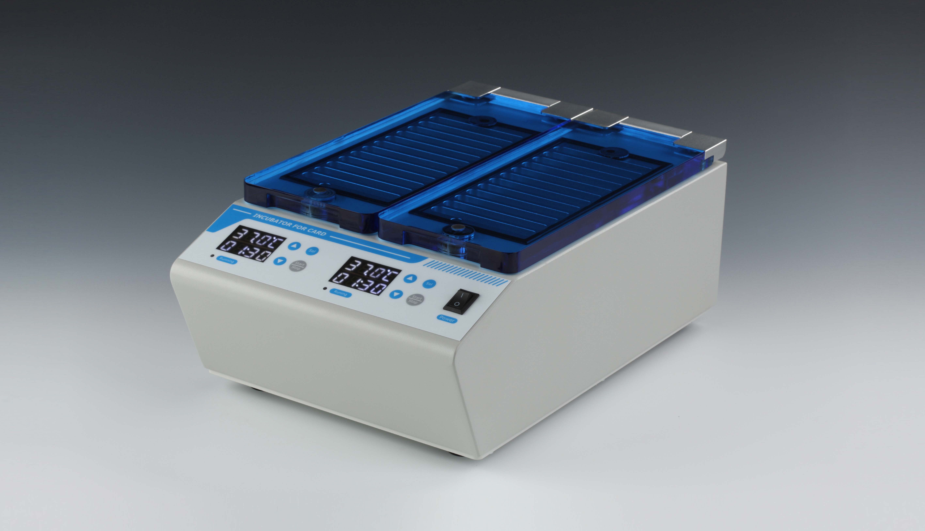
Description:
BTC1000-24 Gel Card Incubator is a special incubator for 37°C blood group card. It is formed by microprocessor technology combined with PID automatic temperature control method. It is suitable for incubation of the solution in the carrier of the blood group reagent card at a temperature of 37°C.
BTC1000-24 gel card incubator can be suitable for many types gel cards from different manufacturers.

Features:
- Capacity: 24 Gel Cards(6-column/8-column).
- Two indenpendent incubation chambers with 12 cards capacity, each working independently.
- Remaining processing time and temperature are shown on the digital display designed for two independent incubation chambers.
- Automatic fault detection and alarm function
- After opening the cover, the reagent card is lifted automatically, that is convenient for the operator to extract the reagent card.

Parameters:
Model | BTC1000-24
Capacity | 24 Gel Cards(6-column/8-column)
Time range | 1sec-99min59sec/∞
Temperature setting range | 26°C ∼38°C
Temperature control range | RT.+5°C ∼38°C
Temp uniformity | ≤±0.5°C
Temp stability | ≤±0.2°C
Temp accuracy | ≤±0.5°C
Display accuracy | 0.1°C
Heating time | ≤4min(from 25°C to 38°C)
Max power | 180W
Voltage | AC220V or AC110V/50-60Hz
Fuse | 250V/3A Ф5×20
Dimension(mm) | 364x234x152
Weight(kg) | 8.2

